Fall for The Arts Festival
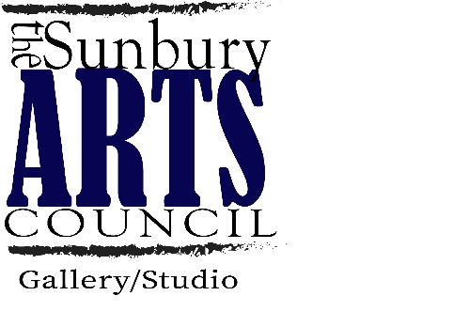
October 22nd 5-10pm
October 23rd 11-4pm
Cameron Park
Sunbury, PA 17801
SunburyArtsCouncil@outlook.com

Name: ___________________________________________________________

Business Name: ___________________________________________________

Address: __________________________________________________________

E-mail: ________________________________________________

Phone Number: ____________________________

What do you make? _______________________________________________

Address to Facebook Page or Website: _______________________________________

One 10 x 10 Space Friday Only $25____Saturday Only____$25 Both Friday and Saturday ____$45
Two 10 x 10 Spaces Friday Only $50____Saturday Only____$100 Both Friday and Saturday ____$90
Food Vendor Friday Only $30____Saturday Only____$30 Both Friday and Saturday ____$50

If you are a NEW vendor this year, 2021, please provide 2-3 images of your work.

Your application will be reviewed as soon as possible. We will notify you directly if you are a vendor, please make sure your payment is sent with application for us to review. Application does not automatically mean you are accepted.

You may email a copy of your application to Sunburyartscouncil@outlook.com or by snail mail to 1242 Highland Ave. Sunbury PA 17801 ATTN: Arts and Curiousities Fest

Each vendor will receive a 10 x 10 space. Only one vendor per space. You may request two spaces but will be required to pay for both.
Vendors must provide their own table and we recommend a canopy, but it is not required.
We DO NOT provide electricity. If you are a food vendor, you must be able to provide your own quiet generator.

Our festival is a juried art festival and we review each vendor application carefully. It is our mission to hand pick artist and makers who align with our festival.
We DO NOT accept Direct Sales.
Please make sure to provide your correct address or email above. You will receive an email ONLY if you are NOT chosen as a vendor. If you do not here back from us via email or phone, we will see you at the event, not need to contact us.
Please remember that you DO NOT have to make specific themed items. Our event allows for a variety of unique and talented artist and Makers.

Our event is Rain or Shine. We suggest you bring a canopy. Please remember that you are not permitted to leave event before 4pm. If there is an emergency or special circumstance, please be courteous and let main tent know what is going on. Failure to give us that courtesy means that we will not accept you as a vendor in the future.
If you are chosen as a vendor and do not show up to the event, please remember that you will not be invited back.

Application Fees are non-refundable.

Vendor Set up information:
Please arrive and be set up an hour prior to the start of your event.
Due to the nature and location of the event, we recommend that you do not leave your tents set up if you are doing both Friday and Saturday. We are not responsible for any stolen items if you choose to leave your tents set up overnight.
We will provide a map of vendors one week prior to the event, located on our events page. Please print this or save it so that you will know where to go the day of the event.
Your space is 10 x 10, please do not go over your space lines.
There will be a portable restroom available near 3rd street.
Please be courteous and do not smoke at your tent.

Parking Information:
There is a parking lot located behind the courthouse and behind the masonic building on Woodlawn avenue that is Free. You do not need to feed meters on Weekends or evenings in Sunbury.

